# Creating the get_response() function

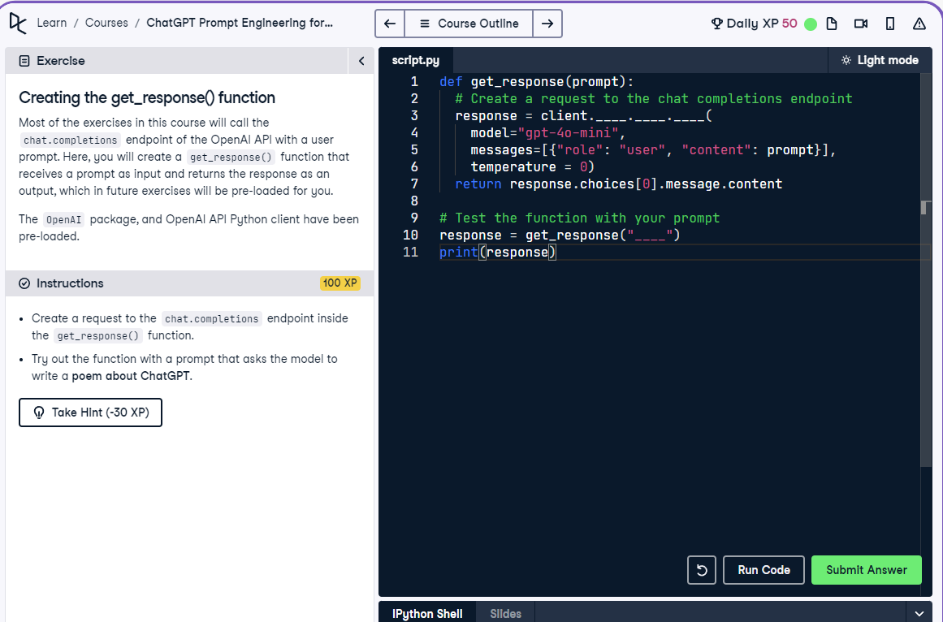

## Question

Creating the get_response() function

## Question Explanation

You need to implement the get_response() function using the OpenAI API to handle user prompts and return completions. The function should create a completion request to the chat endpoint with a user message and print the model's response.

## Answer

def get_response(prompt):  
 # Create a request to the chat completions endpoint  
 response = client.chat.completions.create(  
 model="gpt-4o-mini",  
 messages=[{"role": "user", "content": prompt}],  
 temperature=0  
 )  
 return response.choices[0].message.content  
  
# Test the function with your prompt  
response = get_response("Write a poem about ChatGPT")  
print(response)

## Answer Explanation

The get_response() function sends a prompt as a user message to the chat completions endpoint. It uses the 'gpt-4o-mini' model and sets temperature to 0 for deterministic output. The function returns the assistant's response, which is printed after a test call with a poem prompt.